Seminar VCS (Verified Carbon Standard by Verra) credit program

VCS greenhouse gases credit program  How the VCS system works and what its international standards are?  What types of projects (forestry, renewable energy, soil carbon etc.) are eligible?  How emissions are measured, validated and verified?  The carbon credit market and related business opportunities  Case studies and real-world experience, discussion  Q&A  Seminar is taking place in MS Teams | 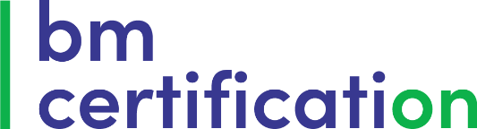  DATE:  09.10.2025  TIME:  10:00 – 14:00  PLACE:  MS Teams  FEE:  free  SUPERVISORS:  Harshini Rananjali and Ülo Roop  SEMINAR is in ENGLISH

